Pembrokeshire

1. Bot will Enter the link in Search engine <http://planning.pembrokeshire.gov.uk/swiftlg/apas/run/wphappcriteria.display>

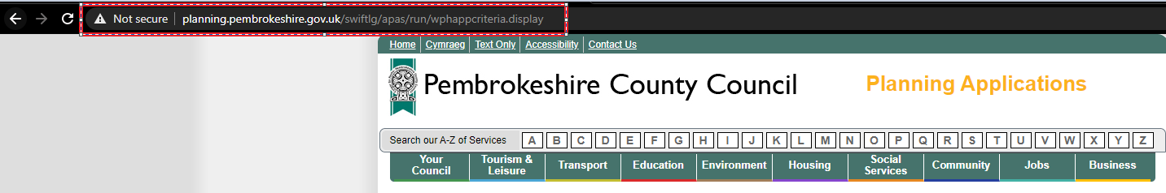

1. In **“Location”** field, Bot will enter first line of property address **(house number/name and street) &**
2. Click **“search”**

Note: We didn’t get an site address to search, so we given bot keywords like “Amroth, Narberth, Prembrokeshire” to enter in location field

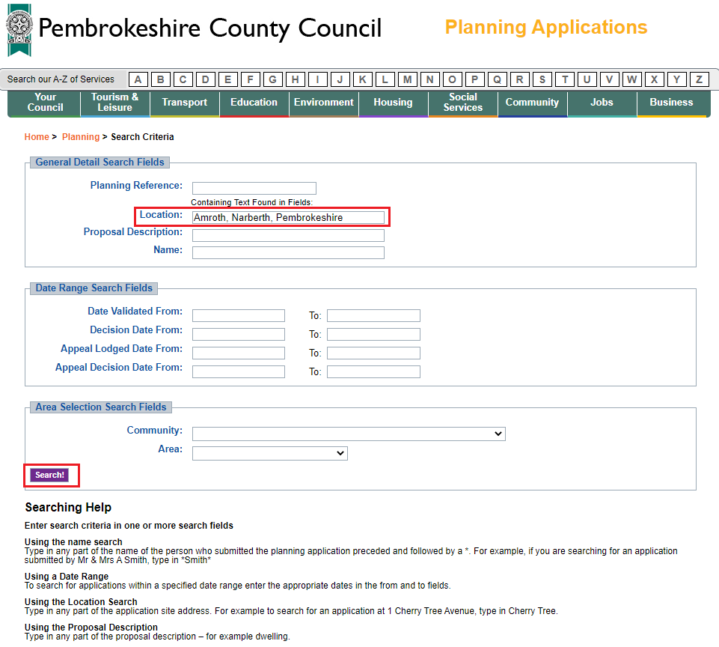

1. Multiple Results has shown for the keyword we searched, Site will list all applications which apply to property.

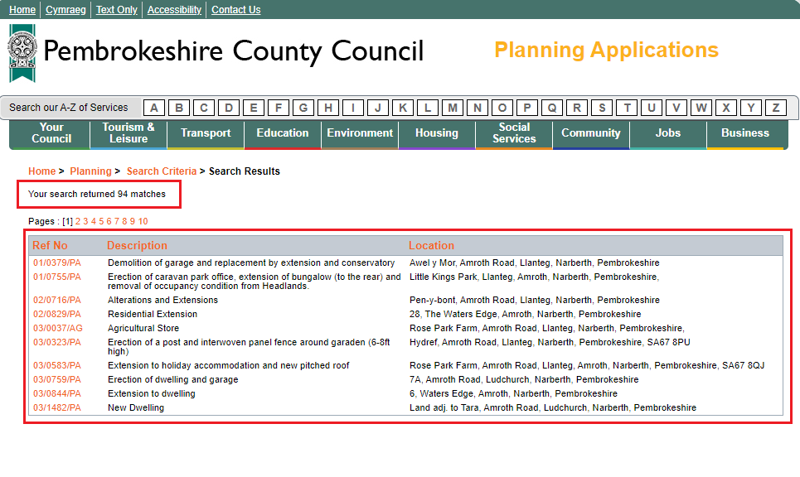

1. Bot will click on **Ref No.** to access full details of any planning applications.

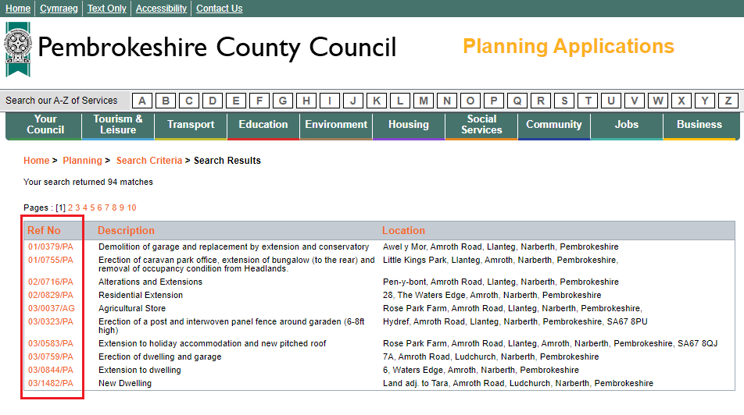

1. The Application details & Address details are shown which are slightly differ compare to other websites

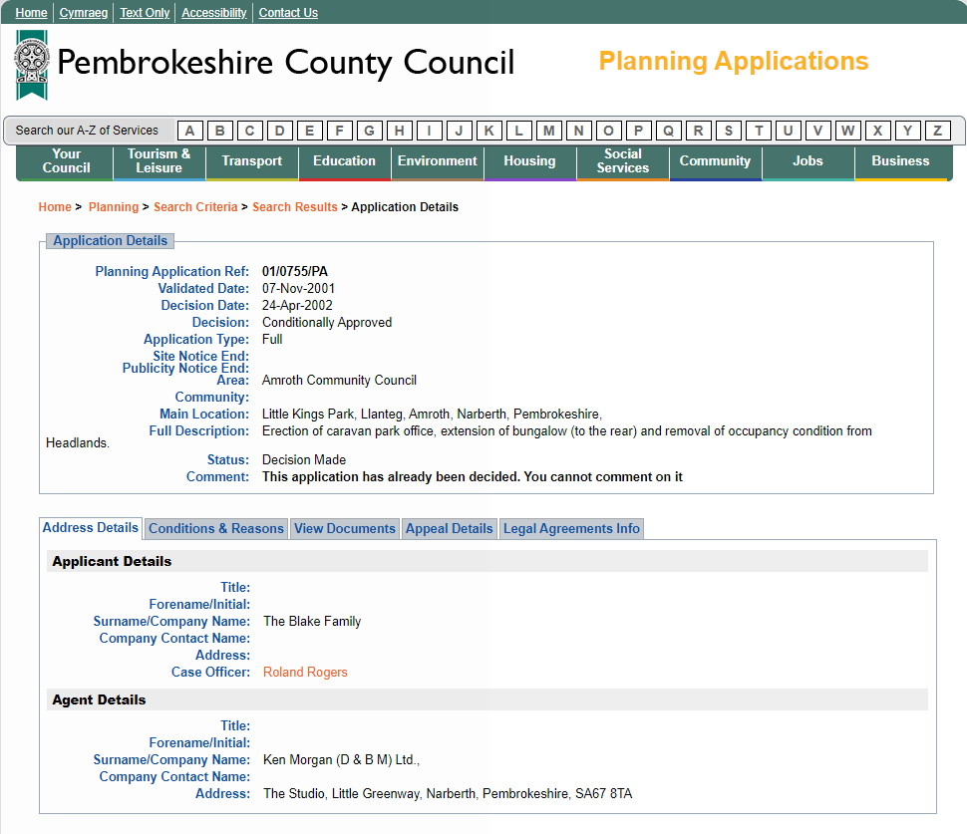

1. So bot has extracted every fields

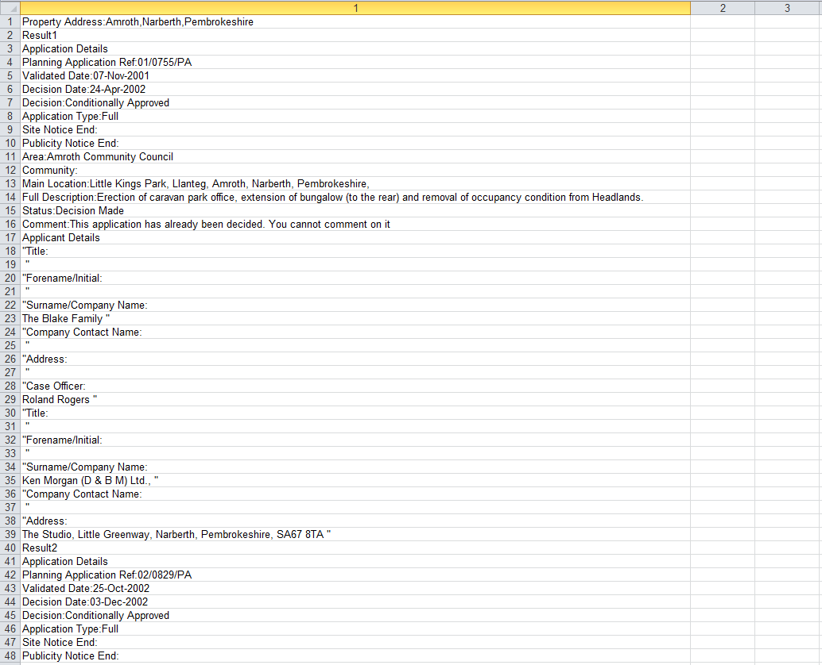

## Questions:

1. What are the fields that the bot need to extract from the application & address details?
2. What are the “tabs” that the bot need to access to extract the fields in it?

Responses:

1. Essential information to be extracted from website as follows:

Planning Application ref

Decision Date

Decision

Main Location

Full description

Status

No further data would be required from any additional tabs.

For trial reasons, you maybe better off trying a specific address, such as:

“Morella, Wooden, Saundersfoot, SA69 9DY”

This may give better responses

Again, spacing of revealed applications could be better as hard to read.